**iRevolution: A Data-driven Exploration of Apple’s iphone Impact**

**1. INTRODUCATION**

**1.1 Overiew**

The world has changed as a consequence of the increasing use of Smart phones, which have improved communication, connected people, and revolutionized many different businesses. With its main product, the iPhone, capturing markets around the world, Apple Inc. has emerged as a prominent player among the top smart phone makers. India, one of the economies with the greatest economic growth, has seen a tremendous increase in smartphone usage, making it an interesting market to study the effects of Apple's iPhone.

In order to shed light on important factors like market penetration, customer preferences, economic ramifications, and societal changes, this research report will perform a data-driven investigation of the impact of the iPhone in India. This study will offer invaluable insights into the transformative impact of the iPhone on India's technological landscape and the lives of its consumers by using advanced data analytics techniques and analyzing large datasets.

Apple has a special chance to increase its market share and develop a significant presence in India thanks to the country's large population and rising smart phone adoption. Each new iPhone model unveiling generates excitement and anticipation among Indian buyers. By utilizing the plethora of information Already accessible, this research aims to go beyond conjecture and anecdotal evidence in order to develop a thorough knowledge of the effects of the iPhone.

**1.2 Purpose**

The main purpose of this project is to give an clear vision to people to know about the Impact of Apple iPhone in India. This study offers invaluable insights into the transformative impact of iPhone on India’s Technological landscape. This research aims to go beyond assumption and anecdotal evidence in order to develop a in-depth knowledge of the effect of the iPhone. The main goes of this project is to know about how Apple’s iPhone has affected business in India.

**2.PROBLEM DEFINATION & DESIGN THINKING**

**2.1 Empathy Map**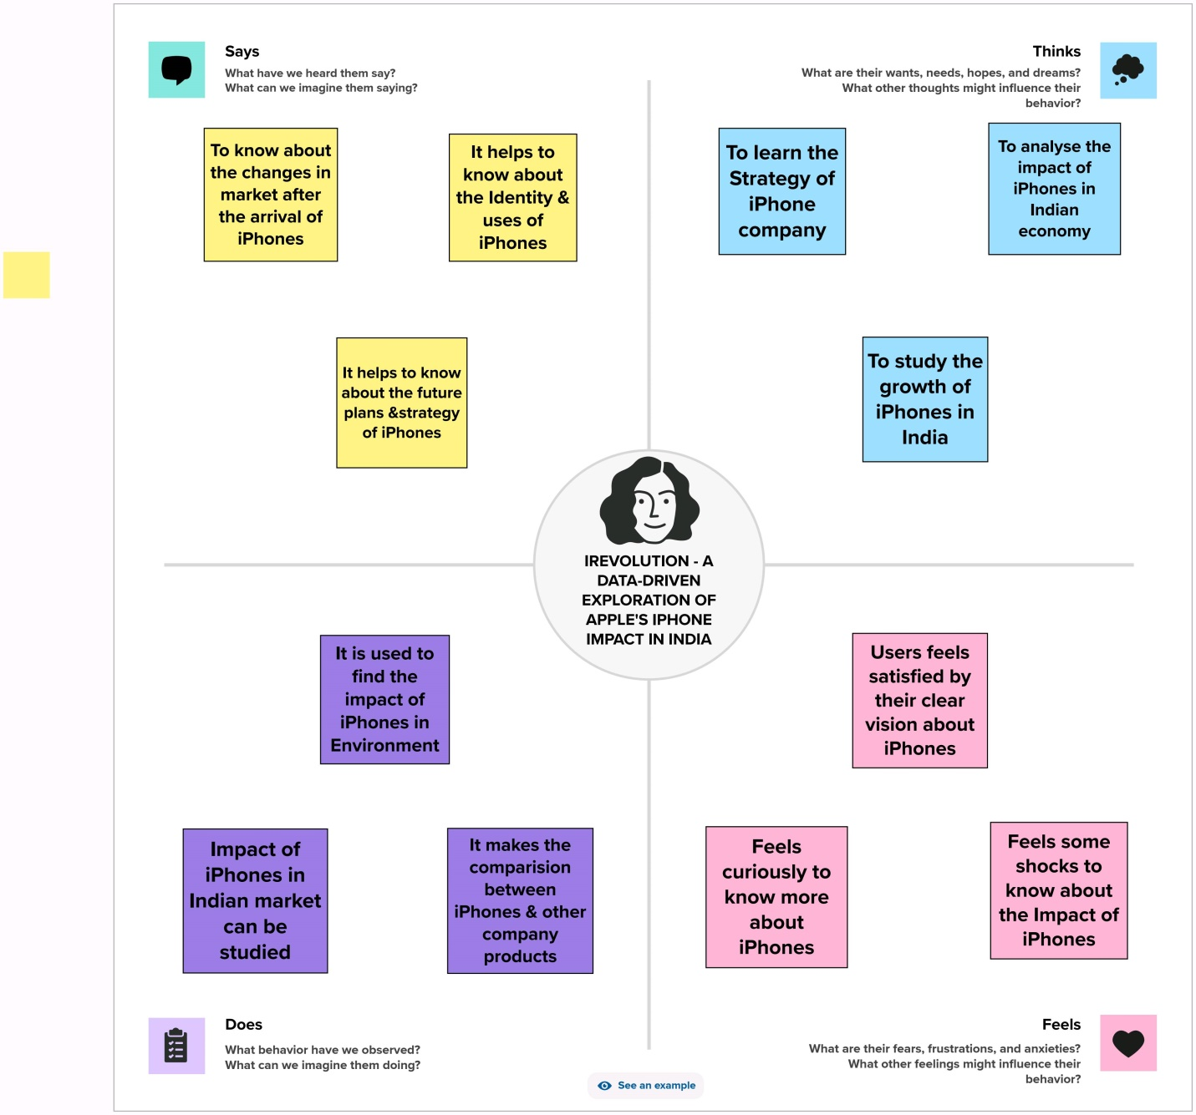

**2.2.Ideation & Brainstorming Map**

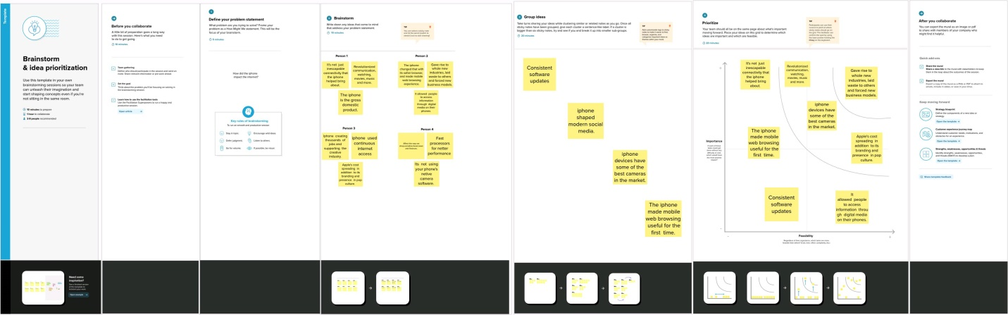

**RESULT** : **Dashboard 1 , Dashboard 2 & Story**

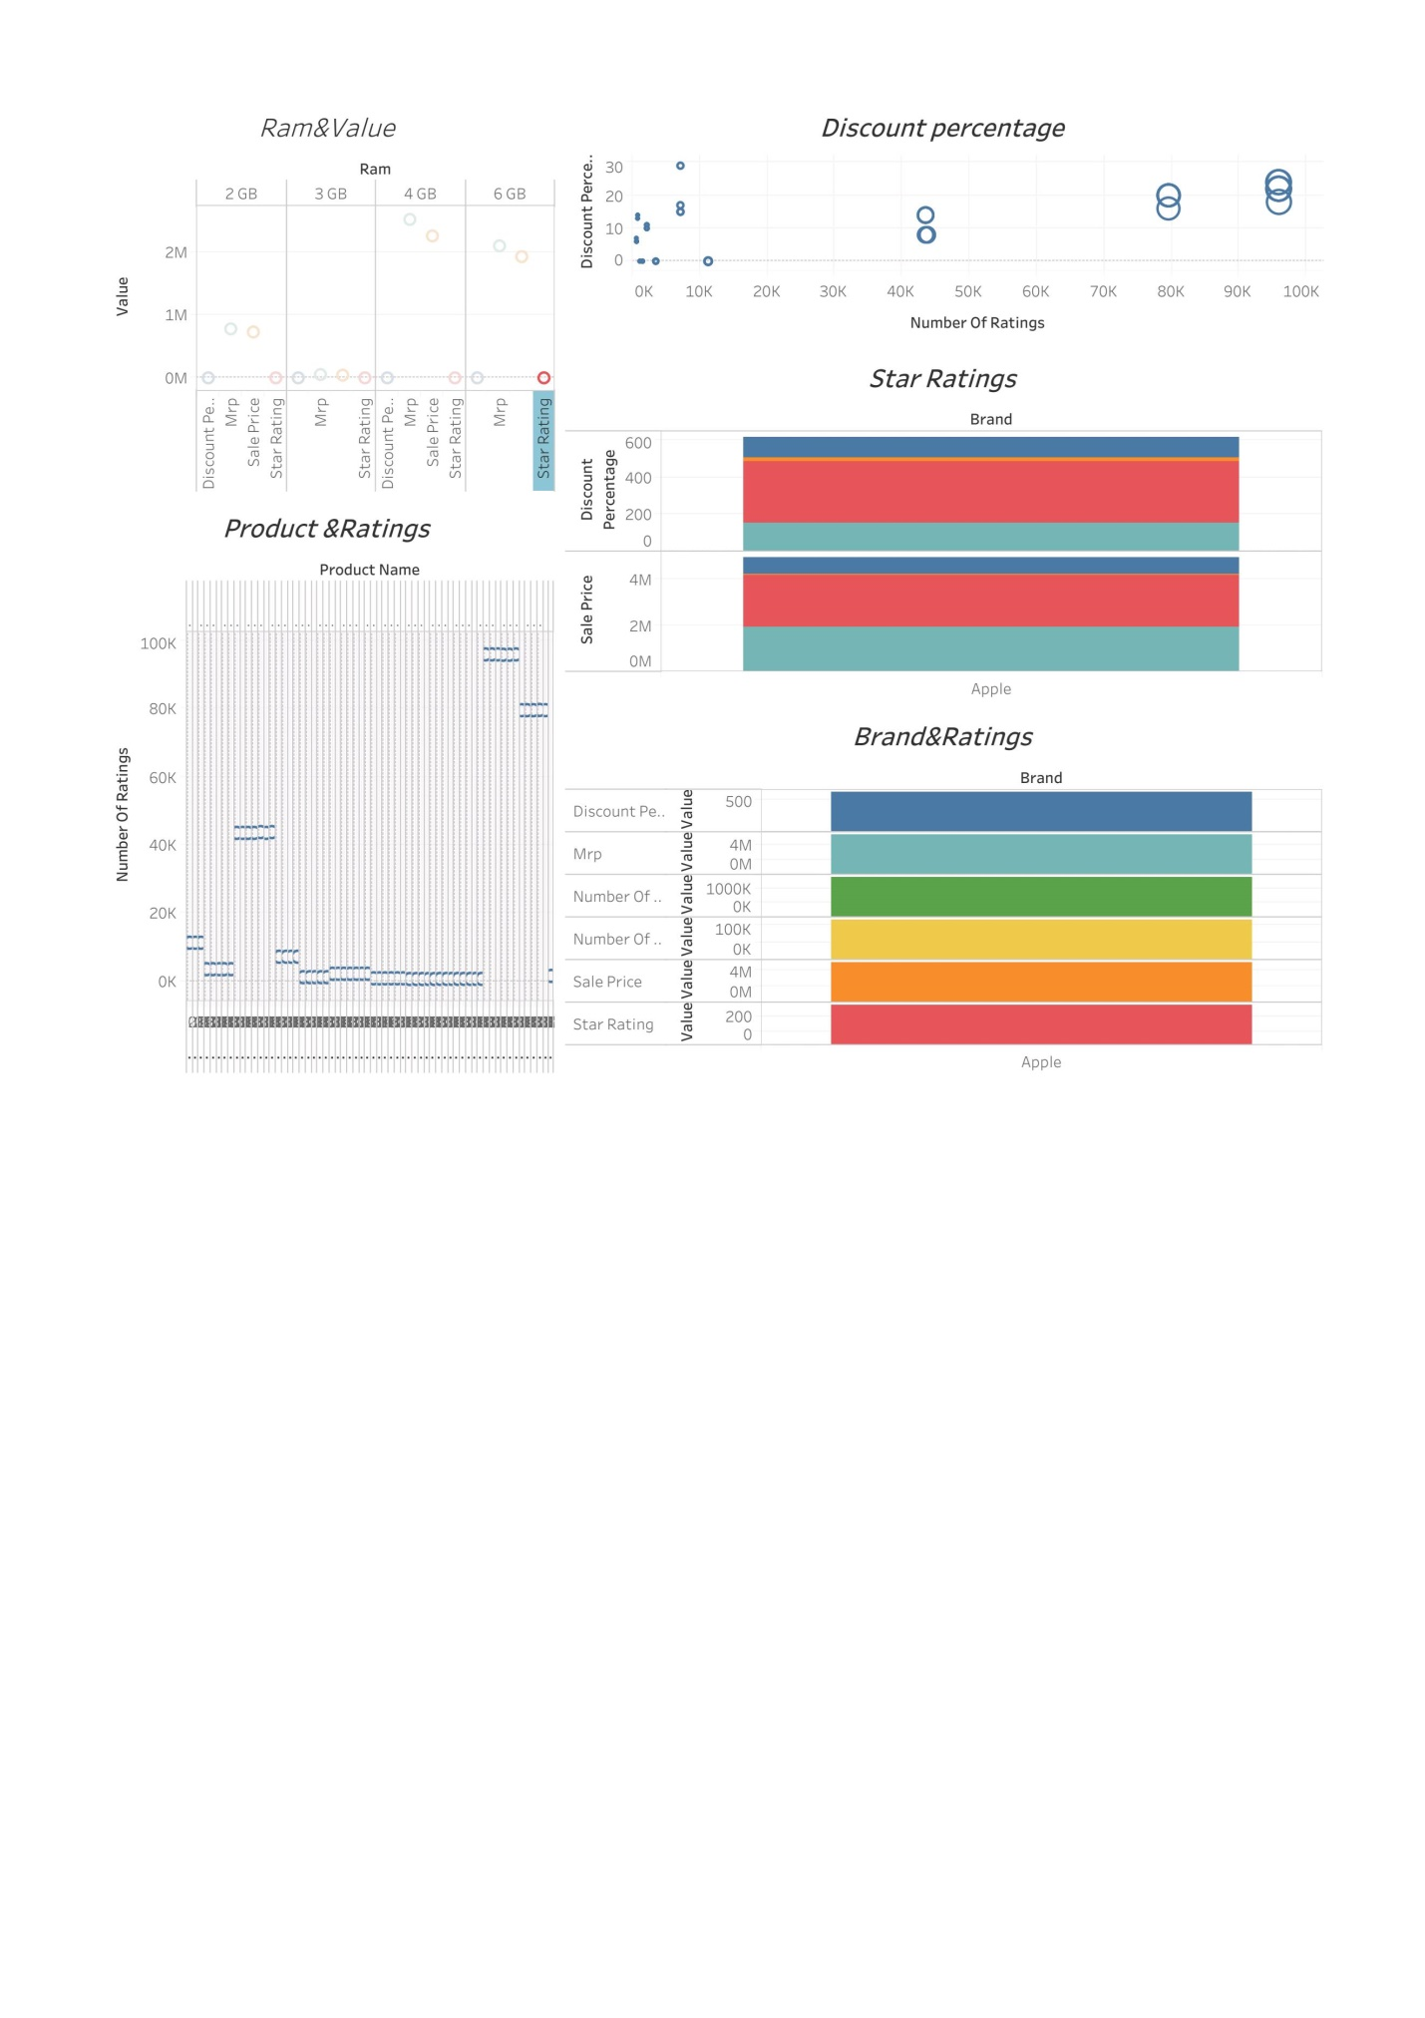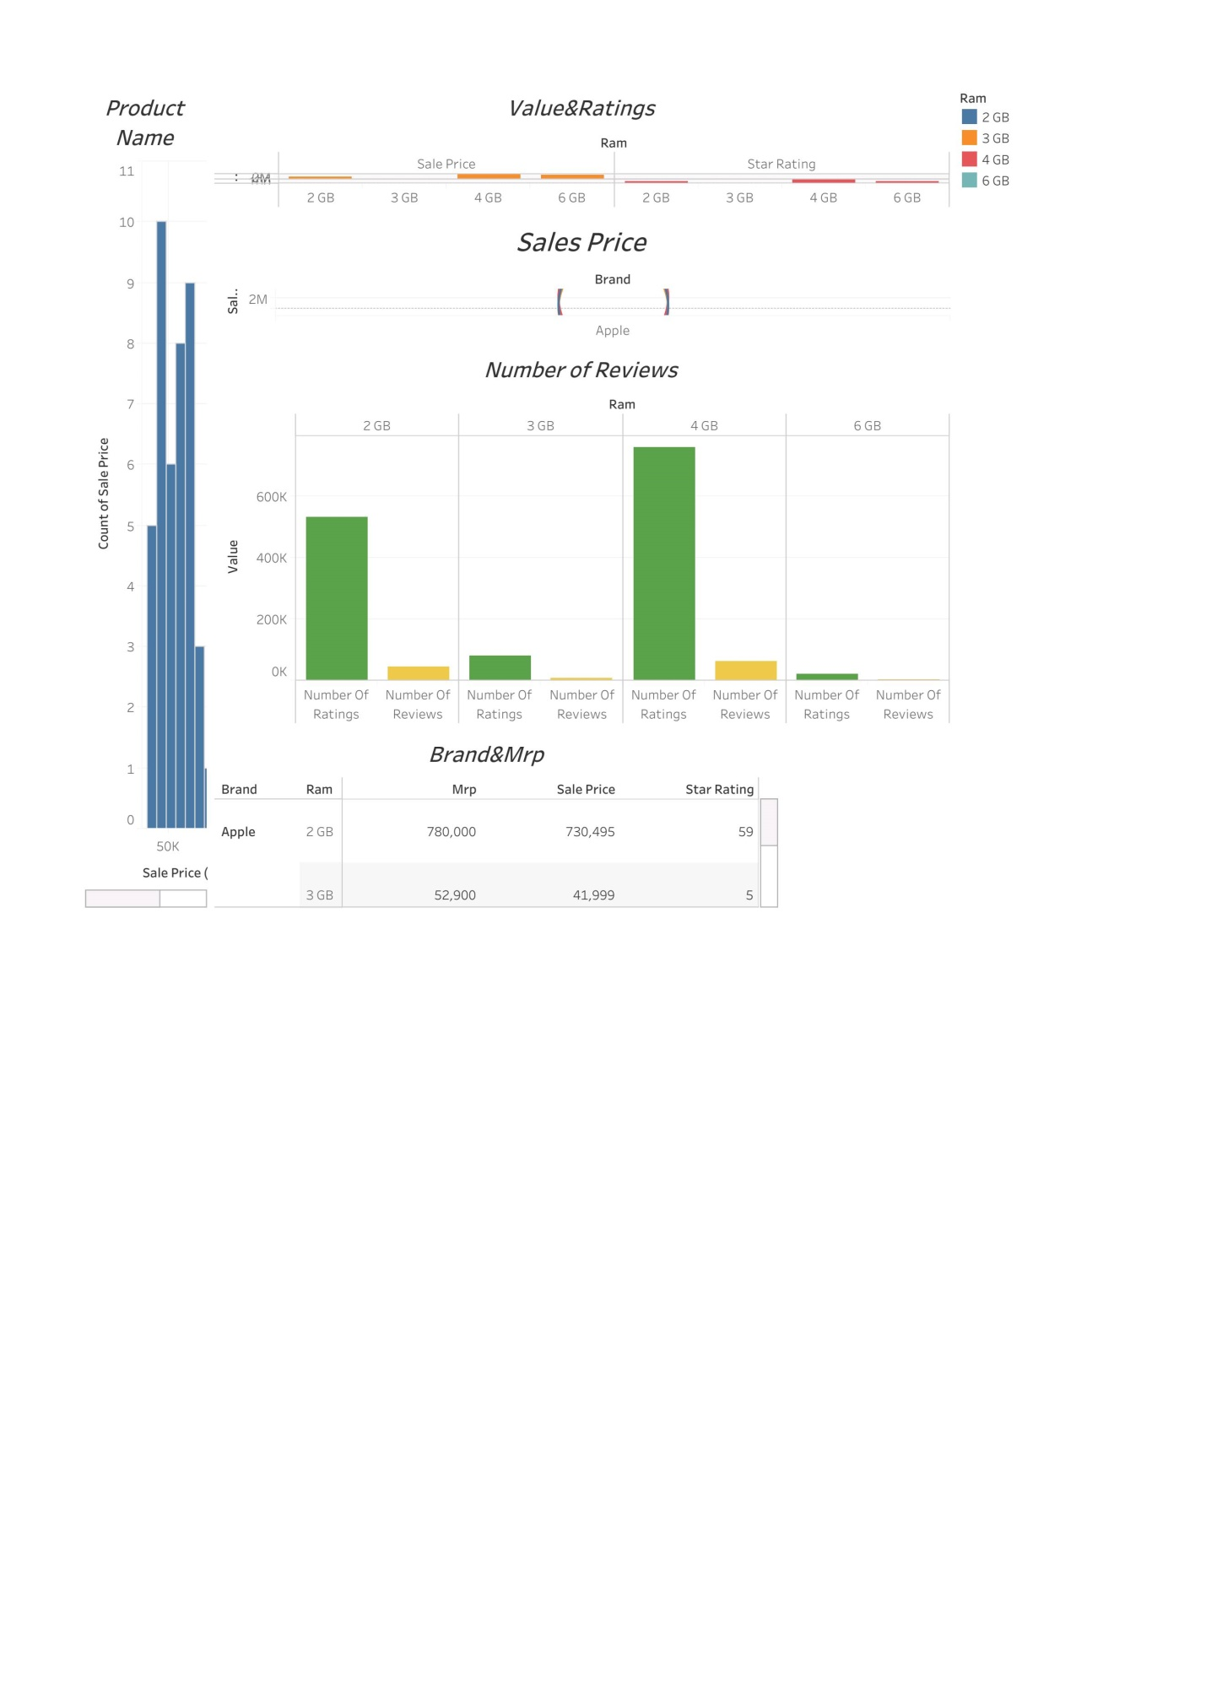 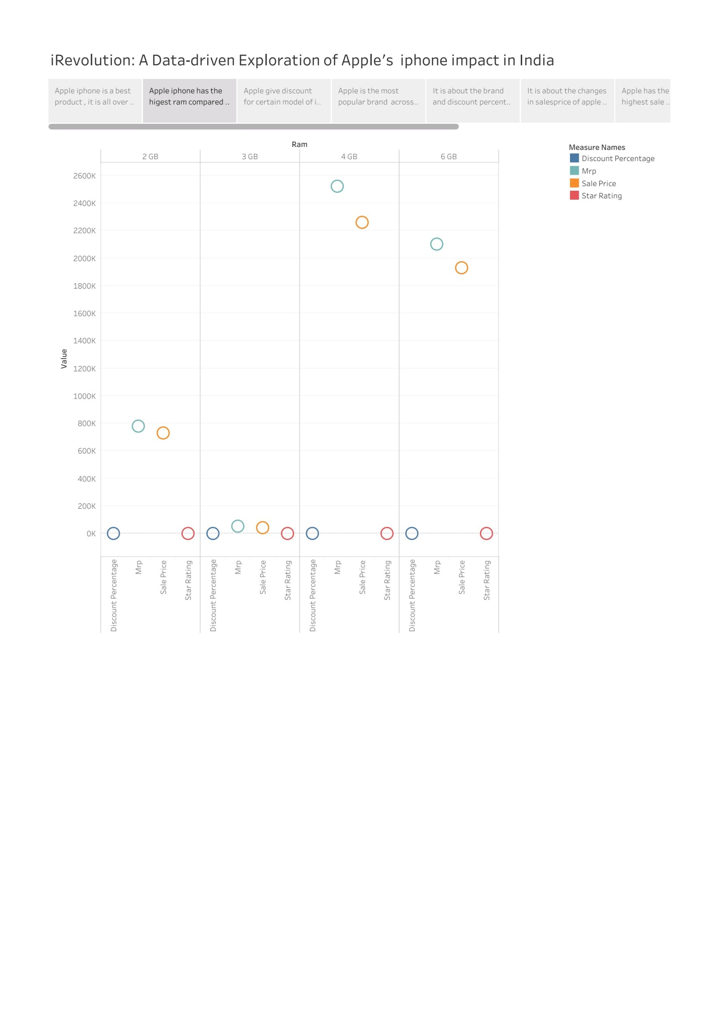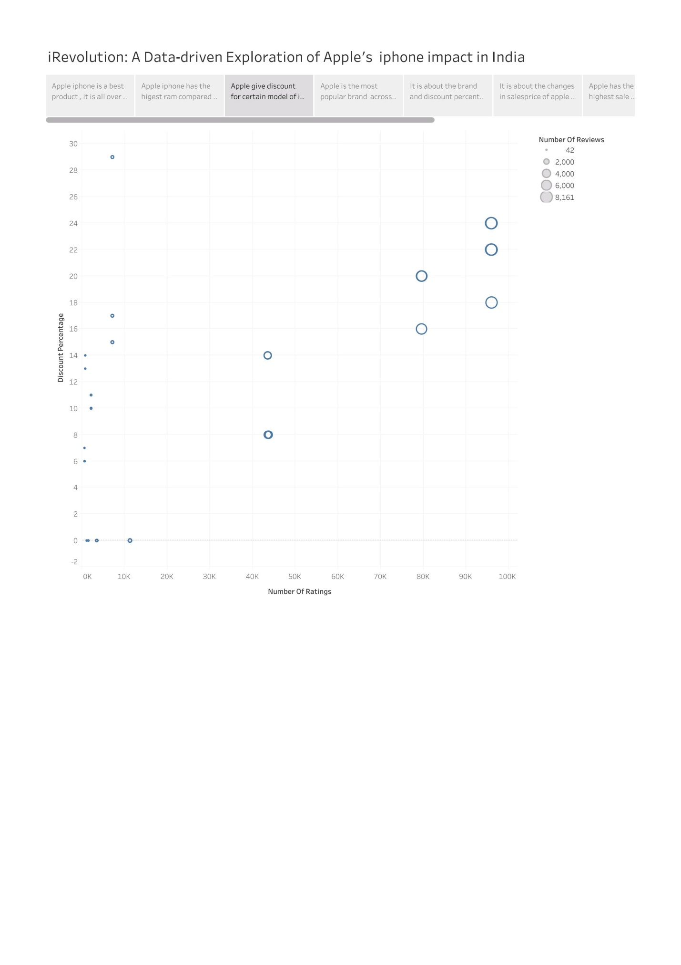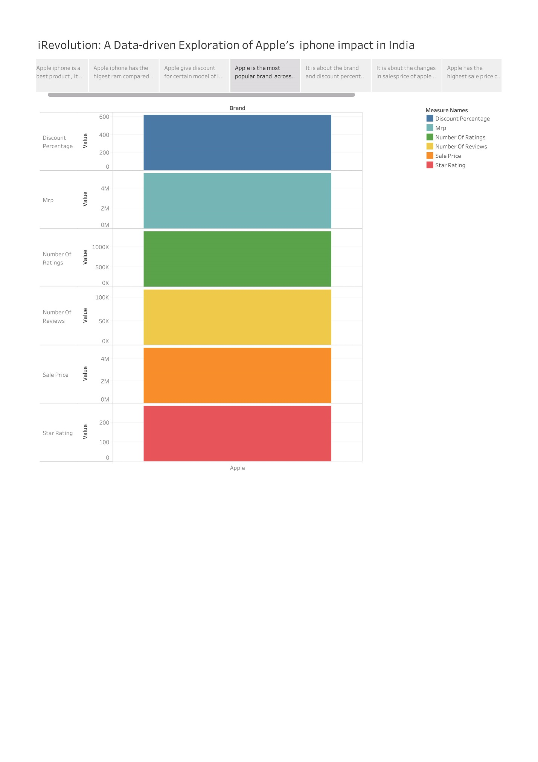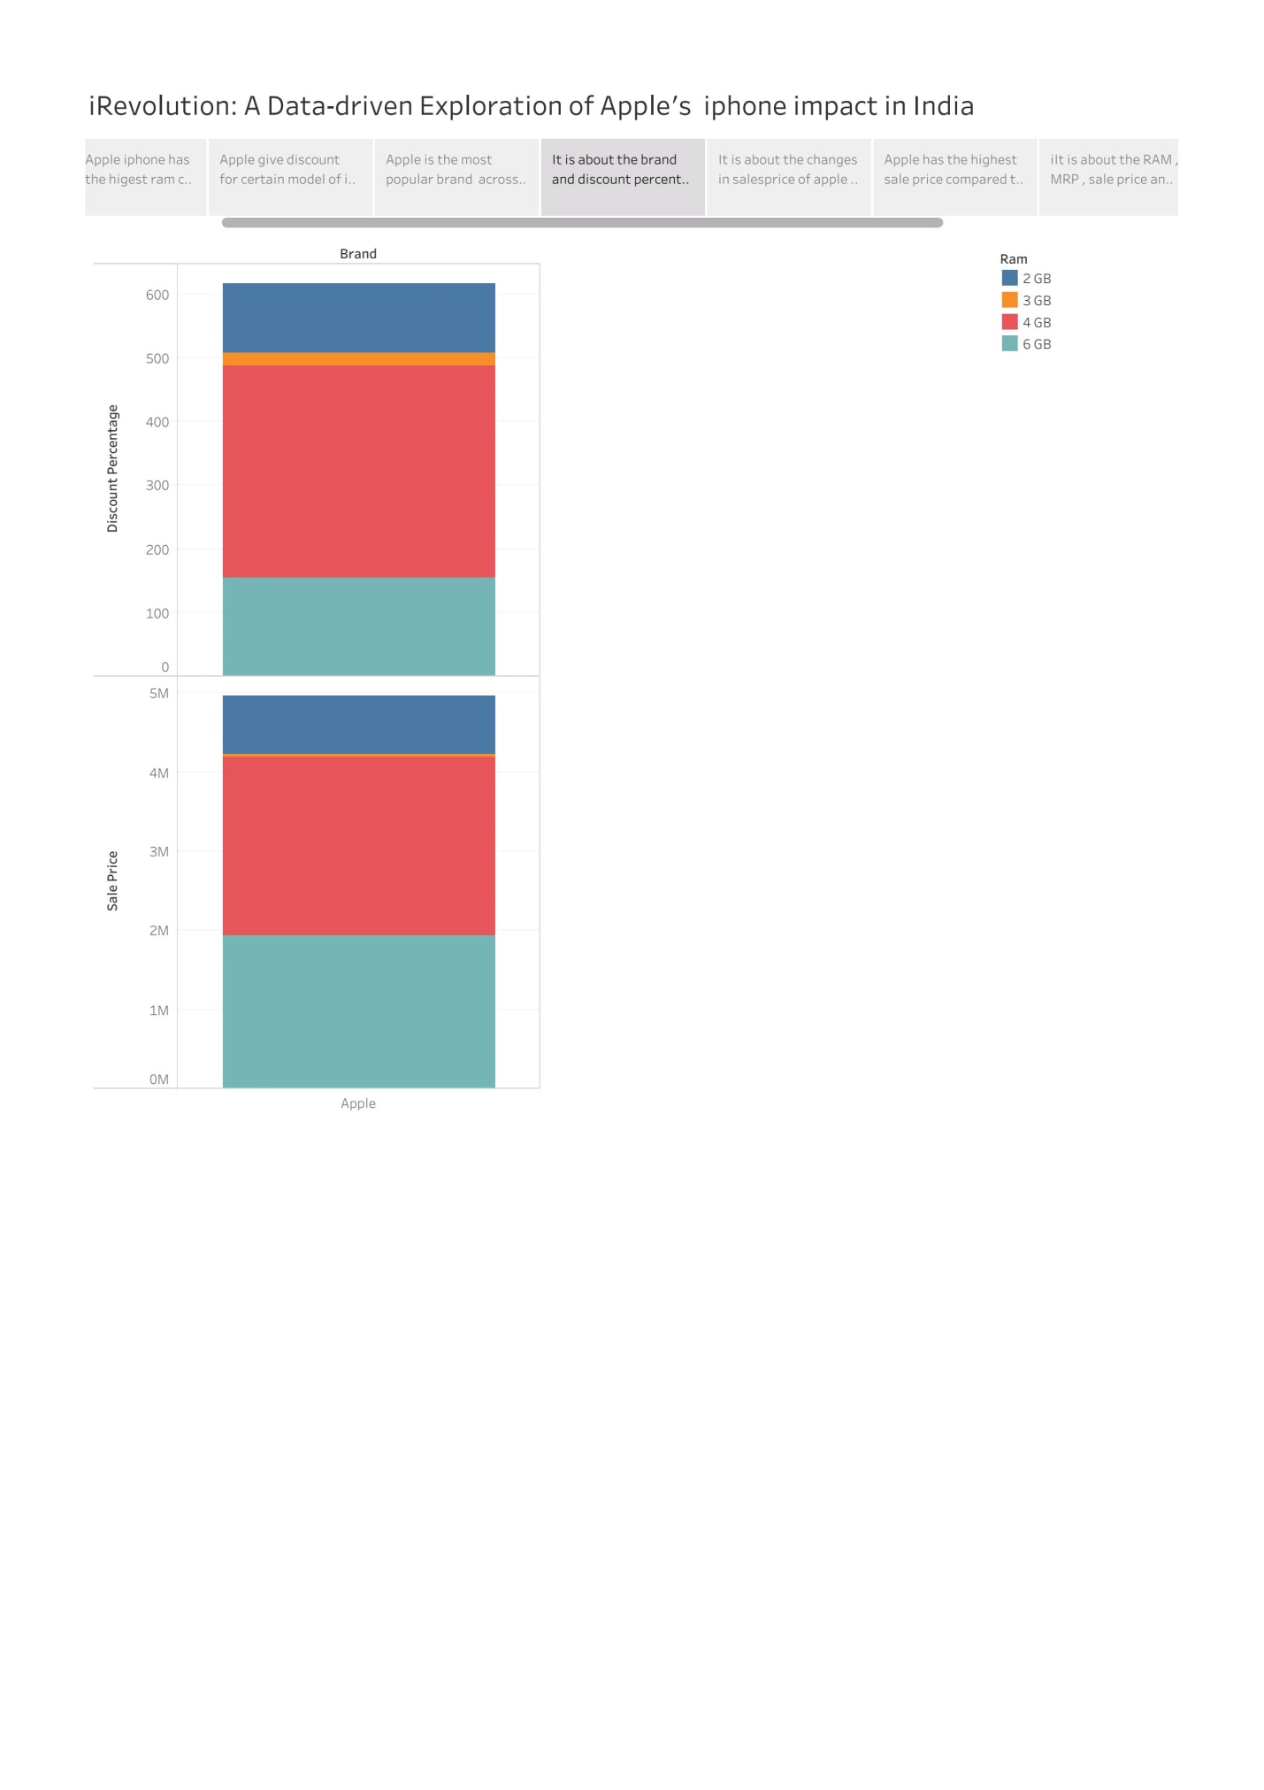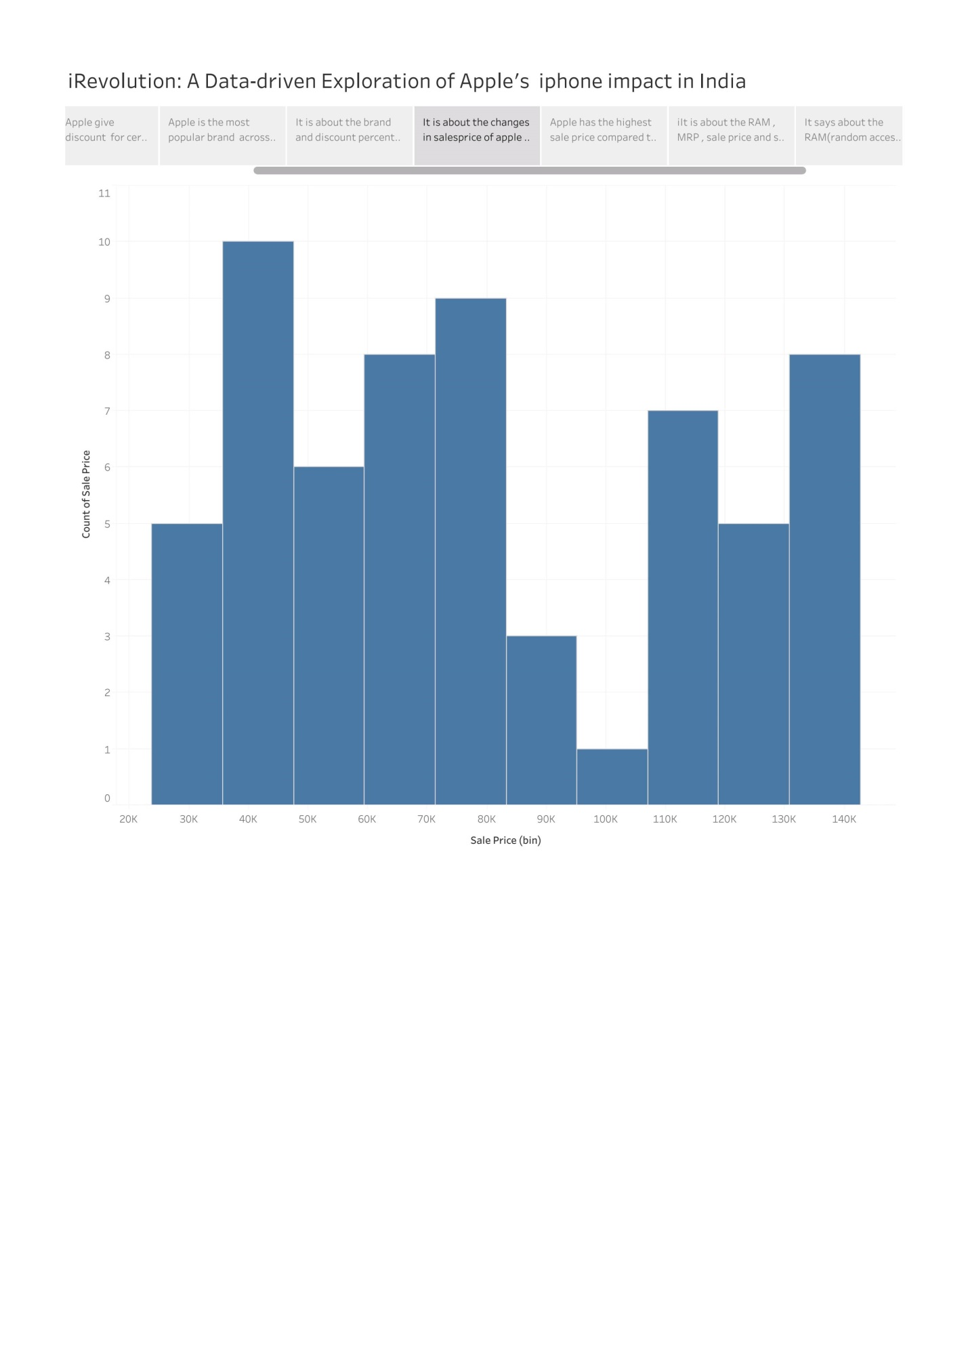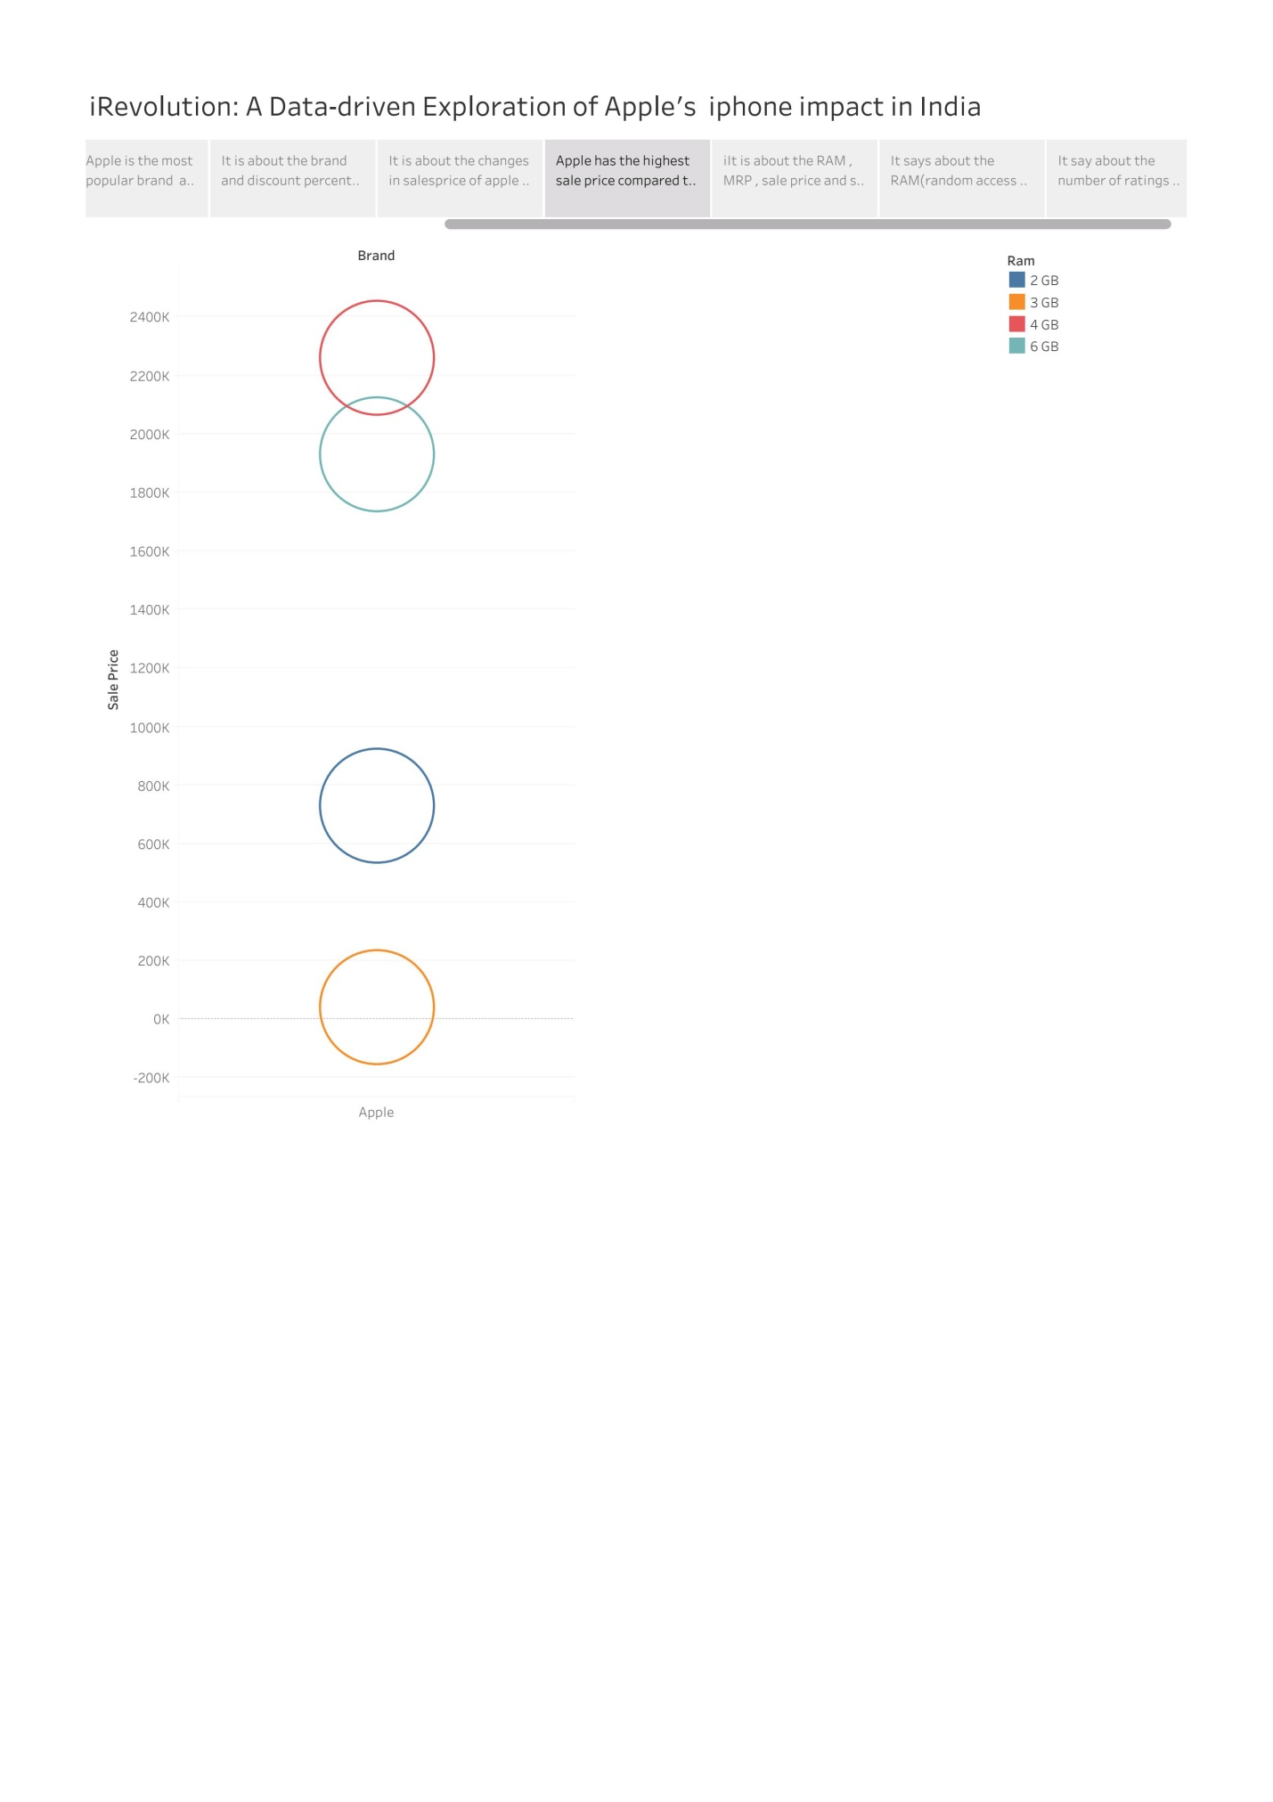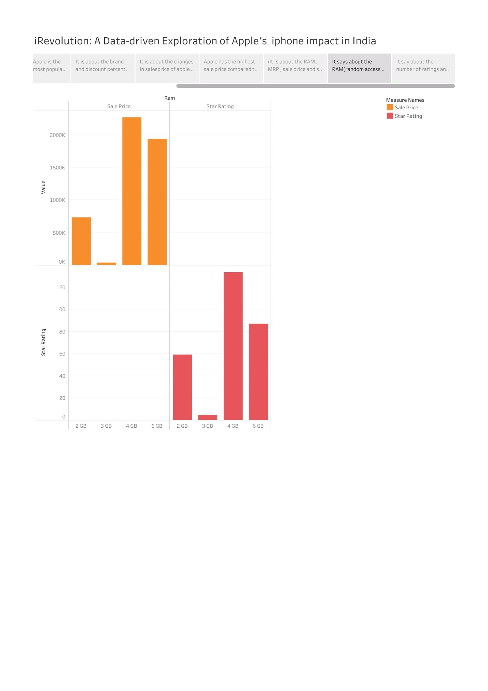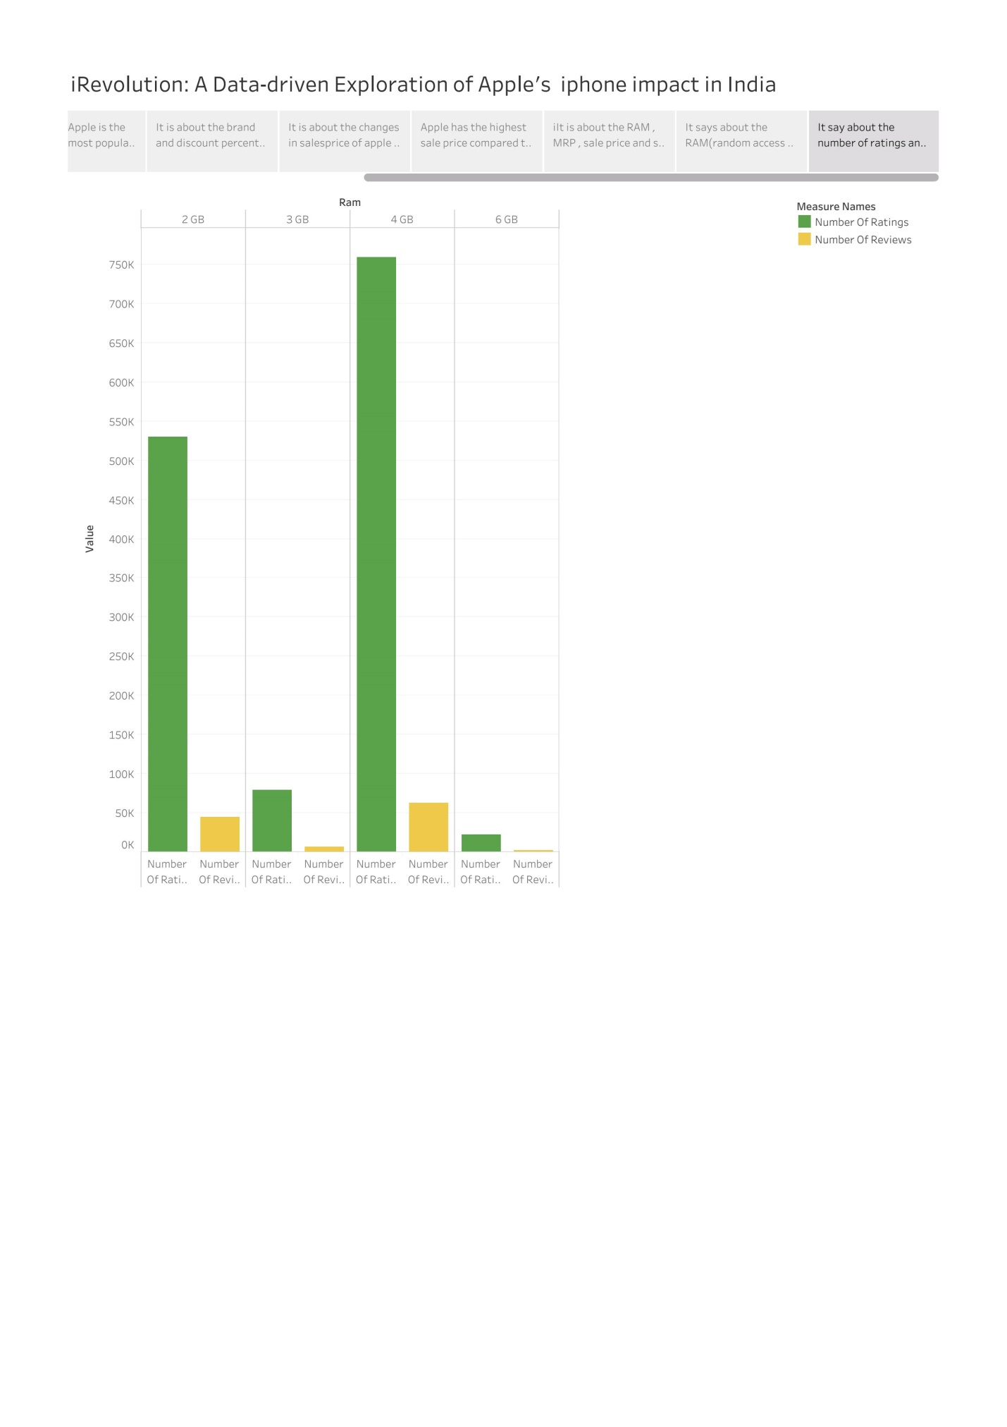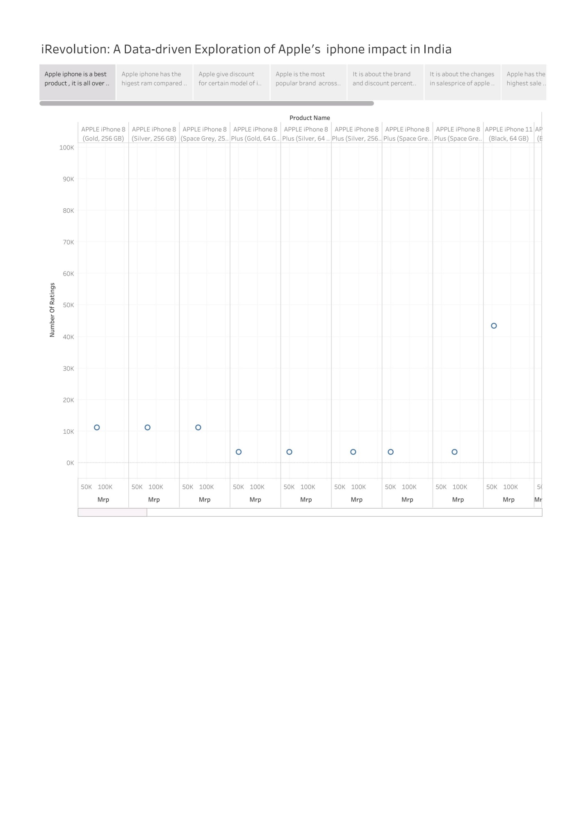**ADVANTAGES**

**➢ This impose looking at customer choices, Market penetration, Socialogical developments, and Economic**

**effect.**

**➢ From this study, we know that the societal impact of Apple’s iPhone Impact in India.**

**➢ This research must focus on, how Apple’s iPhone has affected Bussiness in India.**

**➢ It find Possibilities for growth & innovation by understanding the Business Impact.**

**DISADVANTAGES**

**➢ From this project, Customers know that the Apple iPhones are overpriced compared to other Brands.**

**➢ Customers will know that the Market share of Apple’s iPhone is lower than other products in India.**

**APPLICATIONS**

**➢ Customer can buy a new mobile with their wanted features by using this Project.**

**➢ When people enters into this Mobile field ,they can know necessary basic information like sales share, Brand price comparison ,Annual revenue and other details about Smartphone by applying this project.**

**CONCLUSION**

**Problem Defination & Design Thinking is done by creating Empathy Map and Brainstorming Map. Data Visualization is done by creating graphical representations. The goal of Data visualization is to make complex Data sets more assesible , Intuitive and easier to interpret. Dashboard for this project is created which is cruicial to ensure that the information is easily understandable and finally story is done which is the way of presenting data and analysis in a narrative format. The main goal of storyboard is making the information more engaging and easier to understand. By build this project we can understood the Impact of Apple’s iPhone in India.**

**FUTURE SCOPE**

**In future, Advantages are generated and the Disadvantages are rectified for Customers Satisfaction and the Data visualization is created with many data sets, so the visualizations gives Interesting Graphs.**